# 1 Research content:

### Superhydrophobic surface theory:

Through the former thorough studies of drag reduction characteristics and mechanisms are investigated which reveal numerous approaches. Applying to microbubbles, the vibrant flexible wall, the polymer drag reduction, traveling wave surface, jet surface, but in this work, we focus on the superhydrophobic surface approaching. According to the phenomenon, the superhydrophobic surface drag reduction operates like a self-clean of the lotus leaf in nature. It allows water rolls easily because of the micro-structure rejecting the water prevent it from falling into the cavity generated by the micro-nanotextures. The interface between water and air created a wall slip that decrease the velocity gradient of the boundary layer led to a decrease in the shear stress, and it is illustrated in Fig. 1.

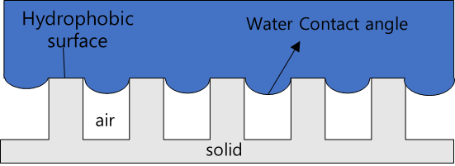

**Figure 1.1** Schematic diagram of drag reduction mechanism of the superhydrophobic surface.

### Superhydrophobic literature survey:

Early theoretical work by Philip (12) obtained the solution for laminar channel flow  
with alternating no-slip/no-shear boundary conditions on one wall, using conformal  
mapping. These results have been widely applied to superhydrophobic surfaces. Laura  
and Stone (13) further extended this solution to pipe flow. The effect of orientation of  
the strips on the overall drag reduction was investigated, and the effective slip length  
for longitudinal strips is twice of that for transverse strips with the same coverage  
ratio. Laminar flows over SHS have been studied both numerically and experimentally.  
SHS has been shown to achieve drag reduction. Analytical models relate  
the slip lengths to various surface parameters such as groove width, pitch, and height  
or the slip velocities to geometry. In general, the SHS is considered to be  
simple grooved geometries, and numerically the interface is typically assumed to be flat  
and represented using zero-shear boundary conditions. Others have included the  
effect of viscosity on the interface. Several authors have investigated the effect of  
the curvature due to the meniscus and modified the analytical solutions to take curvature  
into account. More importantly, it is proposed that the effective slip length is  
shear-dependent. And the shear-independent slip length can be a limit of more general  
slip behavior. Another extension of Philip is the analytical solution by Sch¨onecker  
et al., (14) which contains the viscosity ratio of two fluids by assuming an approximate  
local slip length as a function of the groove aspect ratio at the interface. Belyaev (14) and  
Vinogradovite described the interface with a prescribed constant local slip length  
to apply the ‘gas cushion’ model. Nizkaya et al. (15) generalized this model to  
include the viscosity ratio and the geometry of the surface using the operator method.  
Busse et al. (16) considered the dissipation of the air-water layer but neglected the  
geometric features of the surface. The dissipation at the interface is included in Maynes  
et al.(17) by coupling between the liquid channel flow and trapped gas pocket. Kamrin  
et al.(18) derived a second-order accurate matrix to describe the effective slip boundary  
condition for laminar shear flow at the mean surface height of an arbitrary periodic  
surface. Wang solved the shear flow over longitudinal/transverse grooves using  
eigenfunction expansions and matching. Ng and Wang (19) studied the partially wetted  
grooves problem but assuming an infinite slip boundary condition at the interface.

### Our research:

In this work, the simulation with three dimensions incompressible single-phase turbulent drag reduction in channel flow with the different cases is used to consider as the model problem, in which the drag reduction is induced by slip on interface and coherent turbulent structure will be considered. The slip boundary condition was applied to the air cavity interface which is considered as flat surface, and no-slip wall was applied at the top of the channel and on the top of every post or ridge. The flow channel has periodic boundary condition applies both in streamwise and spanwise like Fig 1.2. The simulation was using the dimensionless length of channel which was Lx/H = 6 and the width was LZ/H=3 where H is the half-height of the channel. This is the same equally to the value of former channel flow research is 2and of streamwise (X) and spanwise (Z) direction sizes respectively (1). While the simulation does not require dimension, but the results of simulation can compare with experiments that the working fluid was water at , the experiment conducted with a half-height of channel is about 0.15 mm if the post or ridge are assumed to be 30 (2,3). The flow has periodic boundary condition applied in the streamwise and spanwise of the channel. The computational domain and domain sizes for respective cases are also present in Table 1 and the cases of simulation are illustrated in Table 2.

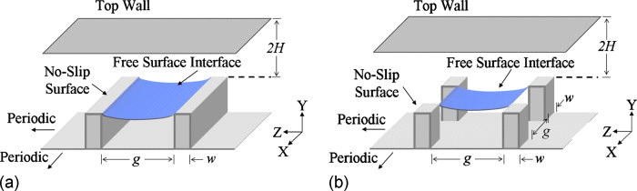

**Figure 1.2** Schematic of geometry and relevant dimension for superhydrophobic surface features. (a) Ridges (b) post. (Note that in the simulation the air-water interface is flat)

TABLE 1. Spatial resolution

|  |  |
| --- | --- |
|  | 180 |
| Computational volume (x, y, z) | 6H2H |
| Grid number | 128 |
| Spatial resolution ( | 7.00,5.0 |
| Spatial resolution ( | 0.34.5 |
| Time integration ( | 18920 |

The direct numerical simulation (DNS) had been implemented by Open Foam, and the algorithm used in Open Foam for unsteady simulation is the PISO algorithm which was the first time proposed by Issa (4) and is presented here for incompressible flow (5,6). Beside that the kind of driving force we were using based on the driving pressure gradient. The coordinates and flow variables of simulation are normalized by the channel width 2H and the friction Reynold number, , in which the friction velocity , where is wall shear, and is density of fluid, , is a half-height of channel and is the kinematic viscosity. The fundamental equations are the continuity and momentum are given by the Navier-Stokes’s equation.

Where , t, and p indicate the velocity vector, time and pressure, respectively. The superscript * indicates that the variables are normalized by H.

TABLE 2. Reynolds numbers, geometric ratios for the study.

|  |  |  |  |  |  |
| --- | --- | --- | --- | --- | --- |
|  | *Geometry* | *g/w* | *w/H* | *g/H* | *Case* |
| 180 | Newtonian flow | - | - | - | C0 |
| Ridge | 1.0 | 0.1875 | 0.1875 | C1 |
| 1.6 | 0.14062 | 0.23436 | C2 |
| 3.0 | 0.09375 | 0.28124 | C3 |
| posts | 3.0 | 0.09375 | 0.28124 | C4 |

In the computation, the implicit time advancement uses second-order Crank-Nicolson scheme for the convection terms. The initial condition flow generates by the equation (11):

Budget of Reynolds Stress and turbulent kinetic energy k. Budget term of Reynolds stress normalized by are expressed as follows:

Production:

Turbulent diffusion:

Vel. p. -grad. corr.

Molecular diffusion:

Dissipation:

The size of ridge or posts of texture effect to the drag reduction on a superhydrophobic surface. It will be changed the value of width of ridge or post but do not change the half height of channel and solid fraction in the simulation at the (The friction Reynold number) which is the value used in our study showed in Table 3. In this work we have conducted with the width and 0.09375 . It is this mean the ratio gap/width is 1, 1.6 and 3.0. It is to equivalent with the sizes of width 28.125, 21093 and 14.0625 , respectively, in realistic experiment (2,3) are shown in the Table 2.

TABLE 3. Mean flow variables.

|  |  |  |  |  |  |  |  |
| --- | --- | --- | --- | --- | --- | --- | --- |
|  |  |  |  |  |  |  |  |
| 180 | 15.72 | 18.38 | 1.17 | 5662 | 3309 | 295 | 8.11 |

In our analysis, we are interested the texture dimensionless parameter that is called the solid fraction, , which is found by calculating the ration between the area of the rough surface on the interface normalized by the projected area of the bottom wall. It is defined by . In the common size found in experiments (2,3) the value of solid fraction is to about 20% (post size are assumed to be 30 , while the range of the solid fraction is 10%-20% (7,8,9) and it is implemented with 6.25% at higher Reynolds numbers. In this study, we considered that is presented in Table 4.

TABLE 4. Reynolds numbers, solid fraction for the cases investigated same geometric ratio’s g/w =3.0.

|  |  |  |  |  |
| --- | --- | --- | --- | --- |
|  | *Geometry*  *(Post)* |  |  |  |
| 180 | *regularly* | + | + | + |
|  | *staggered* | + |  | + |
|  | *random* | + | + | + |

(+) were the cases investigated.

Besides that, we have also investigated the effect of distributing superhydrophobic surface structure on drag reduction in the simulation for the post model and compare the difference between regularly, staggered, and random distribution cases. To generate an idealized surface with randomly distributed roughness, we used a random algorithm with a given the weight where the weight is the solid fraction value. It is presented in Fig.1.3. Through considering the distribution roughness model which has much more effect to drag reduction to. The results could make significant contribution to creation of new superhydrophobic surface.

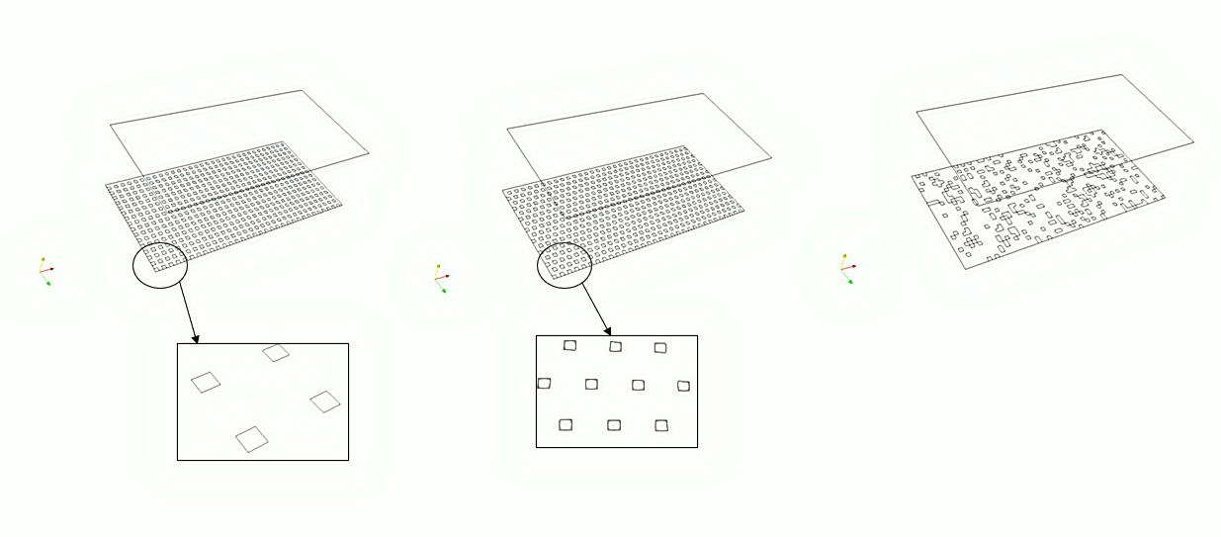

c)

b)

a)

**Figure 1.3** Illustrate the distribution roughness a) regularly model, b) staggered model, c) random model.

One other hand, the study used simulation velocity to investigate the effect of streamwise superhydrophobic surface on the distribution of coherent structures in the turbulent boundary layer. The distribution of the regularly, staggered, and random surface is considered and compared with smooth surface boundary layer, bringing of the correlation between coherent structures and type of the model distribution of surface. Flowing the statistical analysis of the turbulent boundary layer over a smooth surface, the friction velocity ( can be achieved by the linear fit to the logarithmic region in the mean velocity profile (10). The mechanism of turbulent drag reduction with superhydrophobic surface enables us to make clear by turbulent statistic and TKE budget when we compare with original simulation channel flow. The study will focus on the post case with three phenomenal included: regularly, staggered, and random models.

# Results of research and Discussion:

The direct numerical simulation (DNS) of a fully developed turbulent channel by OpenFoam is test case C0 in our simulation (Newtonian turbulent) illustrated in the Table 2 compared Reynolds’s stress profiles and near wall velocity profiles obtained for Moser et al. (11) in Fig. 2.1 with , mean flow variables which is showed in the Table 3, and budget of Reynolds Stress and turbulent kinetic energy k. It demonstrates the profiles of budget of turbulent kinetic energy along the wall-normal direction which we can observe the residual profile is balance are shown in Fig.2.2, so no matter in Newtonian turbulent for channel flow. All value of terms in our simulation has nearly similar values when compared with Moser data. So, this is evidence for the accuracy of our method to apply to simulate on the superhydrophobic surface channel.

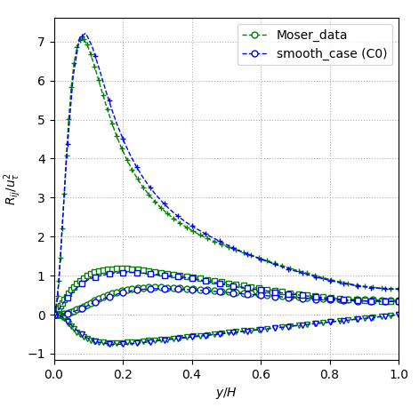 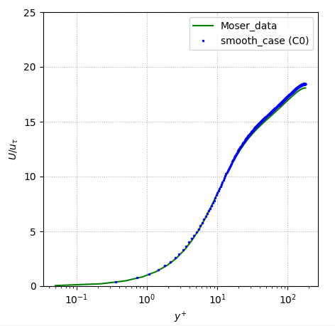

1. b)

**Figure 2.1** Comparation a) Reynolds’s stress profiles b) near wall velocity profiles.

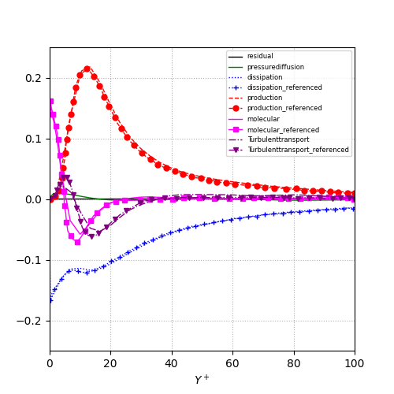

**Gain**

**Loss**

**Figure 2.2** Comparation TKE equation.

Base on the explain above we applied direct numerical simulation (DNS) by OpenFoam to superhydrophobic channel flow which the remain cases is in Table 2 from C1 to C4. We obtained the results about the relationship between ratio gap/width, ridge and post geometry model and drag reduction. The drag reduction (DR) rate will be defined as,

Where: denotes the friction coefficient of the superhydrophobic surface, , is the dimensionless streamwise mean velocity; represents the friction coefficient of the Newtonian flow, , is the bulk Reynolds (12).

The Table 5 shows the drag reduction which the cases investigated. It obtained the drag reduction on the post geometry have more much effect on than ridge cases. The results are close to those of conclusion of Martell and et Table 6. The result help us focus on the post case to investigate the relationship between drag reduction and solid fraction on SHS. The Fig. 2.3 presented the reynolds stress ridge case (C1) which has the most drag reduction in the all of the investigated ridge cases investigated.It also reveal the superhydrophobic surface reduces the mean shear and hence the turbulent production. It also sigificantly reduces the amount of energy dissipation near the surface. Instead of calculate drag reduction Martell and et used shear stress reduction to show relationship between parameters and drag reduction.

**TABLE 5**. Turbulent drag reduction the cases investigated

|  |  |  |  |  |  |
| --- | --- | --- | --- | --- | --- |
| Case | C0 | C1 | C2 | C3 | C4 |
| DR (%) | - | 13.8 | 9.2 | 7.6 | 42.44 |

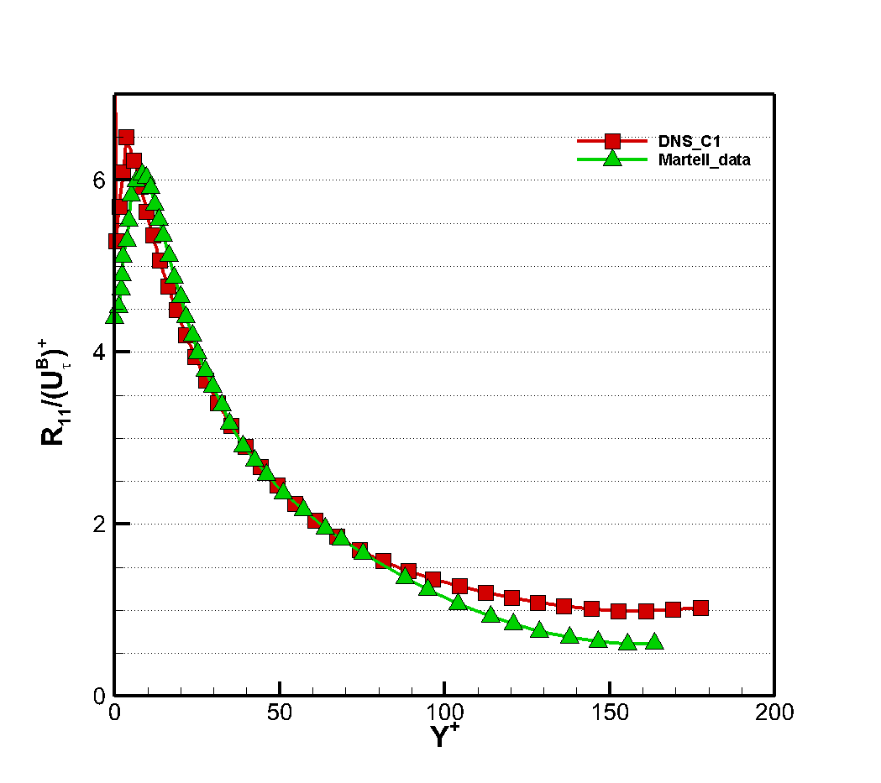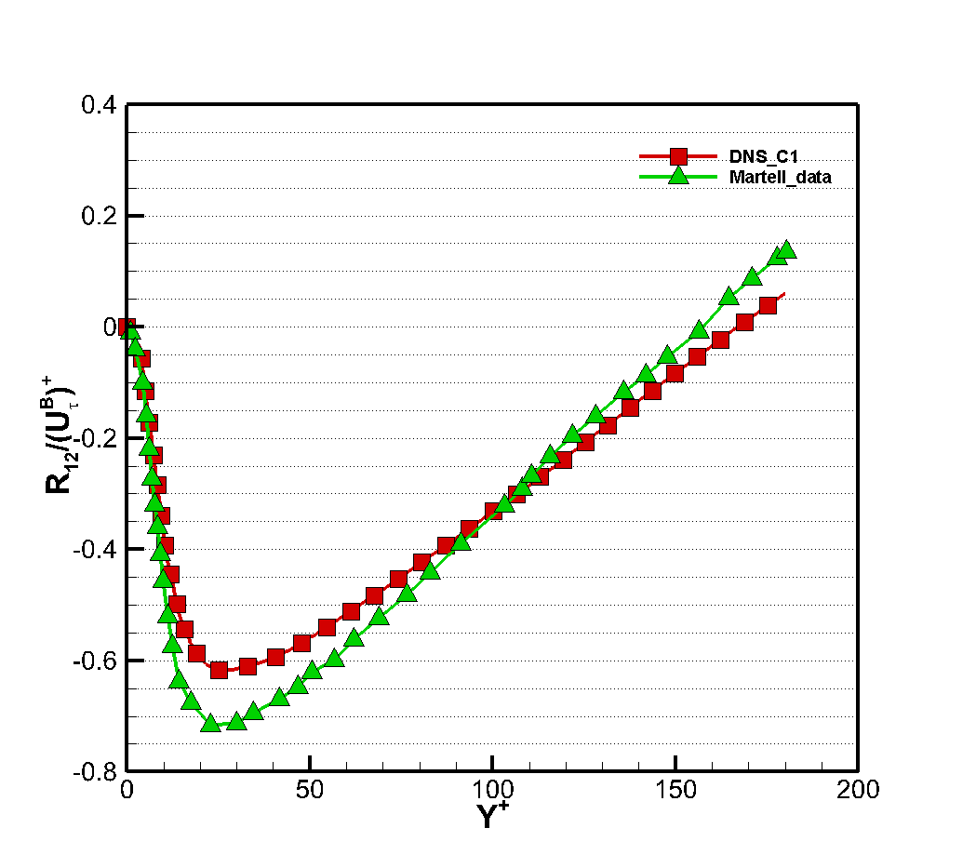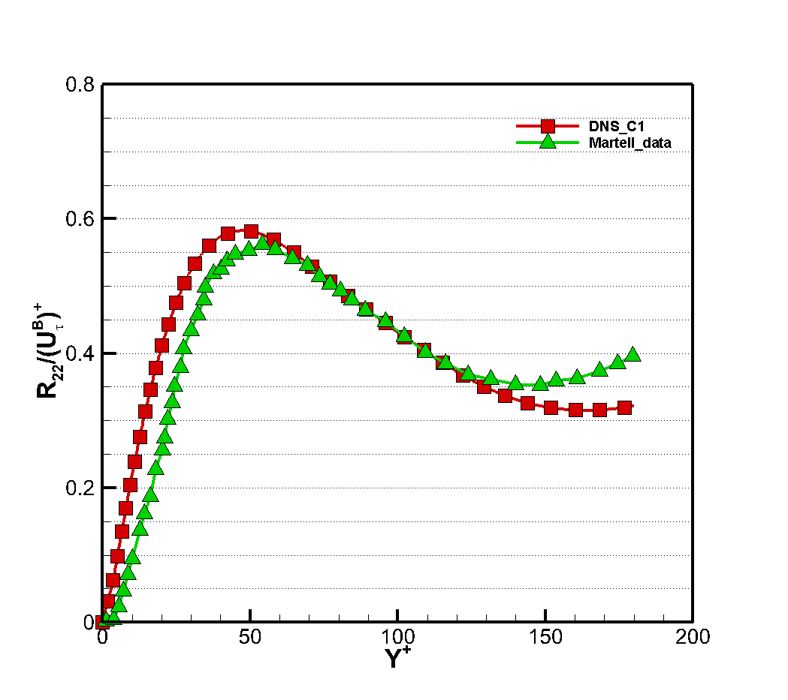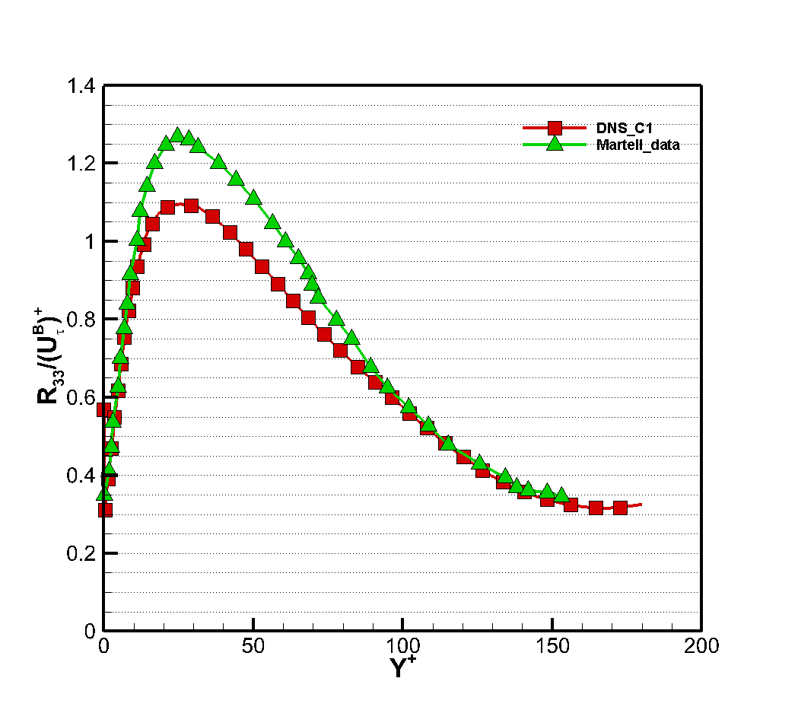

**Figure 2.3** Reynolds stress for Ridge case (C1).

**TABLE 6.** Compare shear stress reduction and slip velocity

normalized bottom-wall friction velocity at =180 for post case

|  |  |  |
| --- | --- | --- |
| Data | (%) |  |
| Martell data | 39 | 20 |
| C4 data | 42.4 |  |

The simulation on the post case with multiple soilid fraction ilusstrates in the Fig 2.4 and Table 7. The drag reduction have a correlation with soilid fraction by linear function. The buck velocity of flow that is a evident show how to drag reduction increases when we change the soilid fraction. So we have a conclution that the bulk velocity is proportional to the drag reduction.

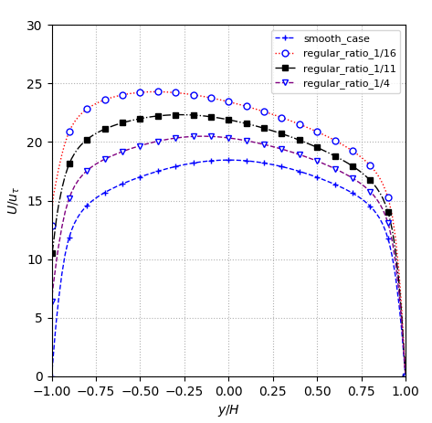

**Figure 2.4** velocity profile (smooth case and another case regular).

**Table 7**: Turbulent drag reduction .

|  |  |  |  |  |
| --- | --- | --- | --- | --- |
| Case | original | =1/4 | =1/11 | =1/16 |
| DR (%) | 0 | 25.91 | 35.76 | 42.44 |

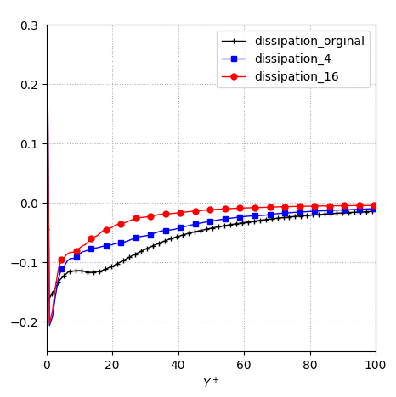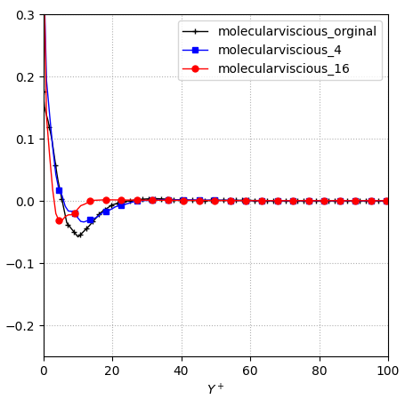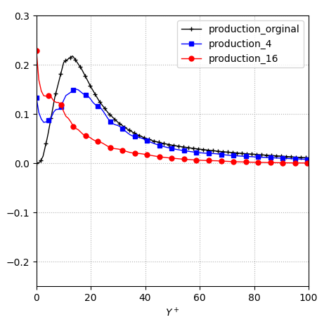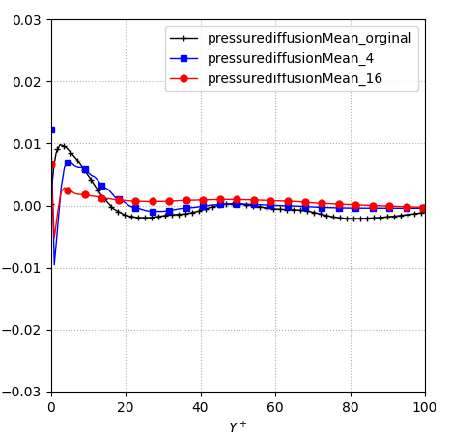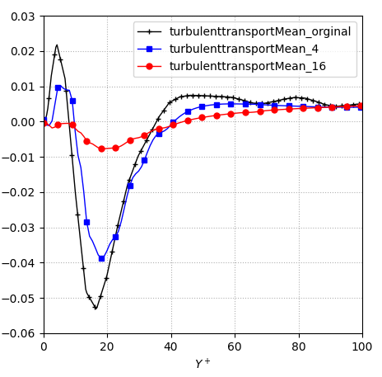

c)

b)

a)

e)

d)

**Figure 2.5:** Analysis on the balance of turbulent kinetic energy. a) Dissipation

b) Production c) Molecular viscous d) Turbulent diffusion e) Pressure diffusion

At Fig 2.5 a) demonstrate the profile of TKE dissipation along the wall-normal direction. It can be achieved that no matter in Newtonian turbulent flow (*Original case*) or in turbulent drag-reducing flow with SHS, is always negative, which means the turbulent kinetic energy is dissipated. Besides that, is large in the near wall region and is reduced away from the channel wall. And in turbulent drag reducing flow with SHS is smaller than that in Newtonian turbulent flow because the viscous of SHS change the transport of TKE and thus the dissipation of TKE is suppressed and reduced. From Fig 2.5 b) We can see the above pictures that the TKE production in turbulent drag-reducing flow is far smaller than that in the original case (Newtonian turbulent flow), the peak value of is only 71% and 48% of that in Newtonian turbulent flow for solid friction value 1/4 and 1/16, respectively. The reason for the dramatic drop of can be attributed to the decrease of Reynolds shear stress in turbulent drag reducing flow Fig 2.5 c) indicates that no matter for the Newtonian or the turbulent drag reducing flow by superhydrophobic surface (SHS), the influencing zone of viscous diffusion focuses on the near wall region. In transition layer, the viscous diffusion achieves the minimum value, which means the energy dissipation induced by viscous diffusion is maximum. The peak value of in turbulent drag reducing flow (SHS) is reduced obviously compared with that in Newtonian turbulent flow. At the Fig. 2.5 d) it can be observed that the turbulent diffusion in Newtonian turbulent flow is stronger in the near-wall region than that in flow by SHS. I turbulent flow with SHS, the turbulent diffusion tends to be stable after the negative peak, it implies the turbulent fluctuation kinetic energy decrease gradually and tend to be stable. In Fig. 2.5 e) it can be found the variation trend of pressure diffusion is similar to that of turbulent diffusion in Fig 2.5 d).

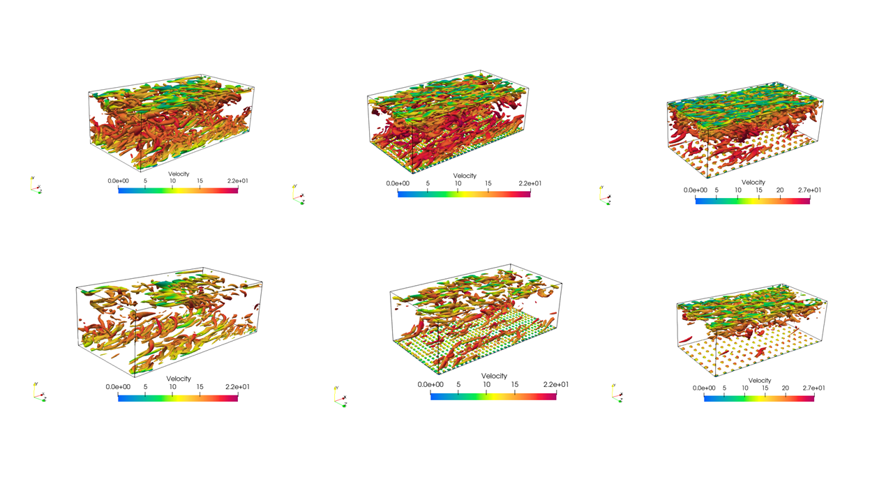Base on above analyses We can have a conclusion that compared with Newtonian turbulent flow, the addition of drag reducing with SHS to turbulent flow obviously changes the production, transport and dissipation of TKE. Especially, The main effect the TKE in the near wall region. The reduction of turbulent drag has close relation with the dramatic decrease of production of TKE. It is also existing the relation between drag reducing with solid friction value which will be explained clearly when we consider with different solid friction value.

=1/16

=1/4

Original

(a)

(b)

**Figure 2.6** Comparison of coherent structures of Newtonian flow and flow with SHS a) Q=100, b) Q =300.

The relation between drag reduction and coherent structures is discussed base on the Fig. It illustrates the turbulent coherent structures of Newtonian flow and SHS cases with Q = 100 and Q = 300, where the vortex tube exists when Q >0 according to the Q method. We can be clearly observed that with the same Q value, the number of vortex tube structures in Newtonian turbulent flow is much more than that in SHS turbulent flow. This indicates that the SHS can be substantially suppress the formation of turbulent coherent structures in turbulent channel flow. When we increase of Q value, the number of coherent structure decrease both in Newtonian and in SHS turbulent flow. And it is also proportional with solid friction in SHS channel.

# Conclution:

1. The superhydrophobic on the post case have more efffective to drag reduction than ridge case.
2. Having the relationship between solid fraction with drag reduction on the SHS. It seem to inverse correlation each other.
3. Simulation results are displayed and drag reducing mechanism is analyzed in detail from the perspective of DR rate, streamwise mean velocity, shear stress, transsport and dissipation of turbulent kinetic energy, coherent srucutres, etc. It is note that there exists distinction in flow characteristics and drag reducing by SHS mechanism between turbulent drag reducing flows at same Reynolds number.

# Research plans:

As the results and explains above, we will improve accuracy Fig 2.3 and find out the relationship between drag reduction and SHS distribution and carry out simulation DNS on the channel superhydrophobic surface with two phases flow to explore the behavior of SHS characteristic on the drag reduction.

# 4 Research reference:

1 R. Moser, J. Kim, and N. Mansour, "Direct numerical simulation of turbulent channel flow up to ," Phys. Fluid 11, 943 (1999).

2 R. J. Dainello, N. E. Waterhouse, and J. P. Rothstein, "Drag reduction in turbulent flows over superhydrophobic surfaces," Phys. Fluid 21, 085103 (2009).

3 R. J. Dainello, "Drag reduction in turbulent flows over micropatterned superhydrophobic surfaces," M.S. thesis, The University of Massachusetts Amherst, 2009.

4 R. I. Issa, "Solution of the implicit discretized fluid flow equations by operator-splitting," J. Comput. Phys. 62, 40 (1986).

5 H. Jasak, "Error analysis and estimation for the finite volume method with applications to fluid flow," PhD. Thesis, Imperial College of Science, Technology and Medicine, 1996.

6 J. H. Furzier, M. Peric., Computational Methods for fluid dynamics (Springer, 2002).

7 R. A. Bidkar, L. Leblanc, A. J. Kulkarni, V. Bahadur, S. L. Ceccio, and M. Perlin, "Skin-friction drag reduction in the turbulent regime using random-textured hydrophobic surfaces," Phys. Fluid 26, 085108 (2014).

8 S. Srinivasan, J. A. Kleingartner, J. B. Gilbert, R. E. Cohen, A. J. B. Milne, and G. H. McKinley, "Sustainable drag reduction in turbulent Taylor-Couette flows by depositing sprayable superhydrophobic surfaces," Phys. Rev. Lett. 114, 014501 (2015).

9 H. Ling, S. Srinivasan, K. Golovin, A. Tuteja G. H. McKinley, and J. Katz, " High-resolution velocity measurement in the inner part of turbulent boundary layers over super-hydrophobic surfaces," J. Fluid Mech. 801, 670 (2016).

10 H. Ling, S. Srinivasan, K. Golovin, A. Tuteja G. H. McKinley, and J. Katz, " Turbulent boundary layers in adverse pressure gradient," J. Fluid Mech. 801, 670 (2016).

11 Robert D.Moser, John Kim, and Nagi N.Mansour, “Direct numerical simulation of turbulent channel flow up to R_tau =590” Phys. Fluid, 11, 943 (1999).

12 J. R. Philip. “Flows satisfying mixed no-slip and no-shear conditions” Z. Angew Math. Phys. 23(3):353-372, (1972).

13 E. Lauga and H.A.Stone. “Effective slip in pressure-driven Stokes flow” J.Fluid Mech., 489:55-77, (2003).

14 C.Schonecker, T.Baier, and S. Hardt. “Influence of the enclosed fluid on the flow over a microstructured sureface in the cassie state” J. Fluid Mech. 740:168-195, (2014).

15 T.V.Nizkaya, E.S.Asmolov, and O.I. Vinogradova. “Gas cushion model and hydrodynamic boundary conditions for superhydrophobic textures”. Phy. Rev. E, 90(4):043017, (2014).

16 A. Busse, N. D Sandham, G. McHale, and M. I. Newton. “Change in drag, apparent slip and optimum air layer thickness for laminar flow over an idealised superhydrophobic surface”. J. Fluid Mech., 727:488-508, (2013).

17 D. Maynes, K. Jeffs, B. Woolford, and B.W. Webb. “Laminar flow in a microchannel with hydrophobic surface patterned microribs oriented parallel to the flow direction”. Phys. Fluids, 19(9):093603, (2007).

18 K. Kamrin, M. Z.Bazant, and H.A.Stone. “Effective slip boundary conditions for arbitrary periodic surface: the surface mobility tensor” J. Fluid Mech. 658:409-437,(2010).

19 C.o.Ng and C.Y.Wang “Stokes shear flow over a grating: implications for superhydrophobic slip” Phys. Fluid, 21(1):013602,(2009).

|  |
| --- |
|  |